--------------------------------------------------------------------------------------------
- Incomplete sentences
Choose the best answer.
- I want to lose weight, so this week I………………..lunch.
a. have b. am not having c.didn’t have d. haven’t
2. My contact at the conference wasn’t exactly a stranger; I ……..her two or three times before.
a. meet b. will meet c. have met d. had met
3. Where ………..Mr. John come from?
a. does b. do c.is d. did
4. The students ………………….. their classes at eight o’clock this morning.
a. started b. have started c. had started d. start
5. He hasn't got ……. about economics.
a. many knowledge b. many knowledges c. much knowledge d. much knowledges
- Last night, when Lucy ……………TV, the telephone……………..
a. was watching/ rang b. watched/ was ringing
c. was watching/ was ringing d. is watching/ is ringing
- I ……a lot of him lately. I know he is still as athletic as he used to be.
a. see b. will see c. have seen d. has seen
8. John ………. tennis once or twice a week.
a. is playing usually b. is usually playing c. usually plays d. plays usually
9. You …….worried. Is something wrong?
a. seem b. seems c. are seeming d. are seemed
10.He usually………. the bus to work, but this morning he took the train instead.
a. takes b. took c. has taken d. had taken
11. I……out of the window when I saw him step out of the house.
a. look b. looked c. was looking d. had looked
12…………Robert lately ?
a. Did you see b. Have you seen c. Do you see d. Are you seeing
13. We will leave the moment he……….
a. arrive b. arrives c. will arrive d. has arrived
14. This year’s job fair in Virginia was known to be a notable………….
a. success b.successes c. succeed d.successful
15…….. can get a brochure on the second floor.
a. To participate b. Participate c. Participants d. Participating
16. The technician instructed all managers in detail concerning the ……… of the new computer system.
a.operation b. operative c. operator d.operate
17.The trainees didn’t have ……… questions about the new system.
a. theirs b. any c. some d. a
18. There are ___ pens in that drawer.
a. a b. an c. some d. any
19. Look at those clouds! It…….!
a. rain b. rains c.will rain d. is going to rain
20. The executives ……… an argument at the moment.
a had b are having c were having d having

II. Incomplete text
Choose the best word or phrase for each blank.
Questions 21 through 23 are based on the following memo.

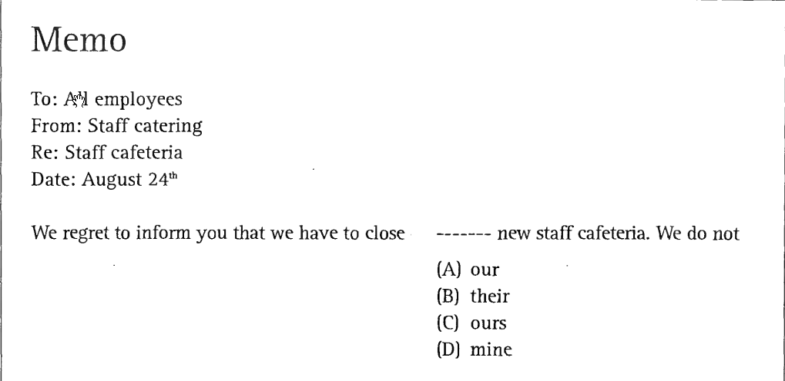
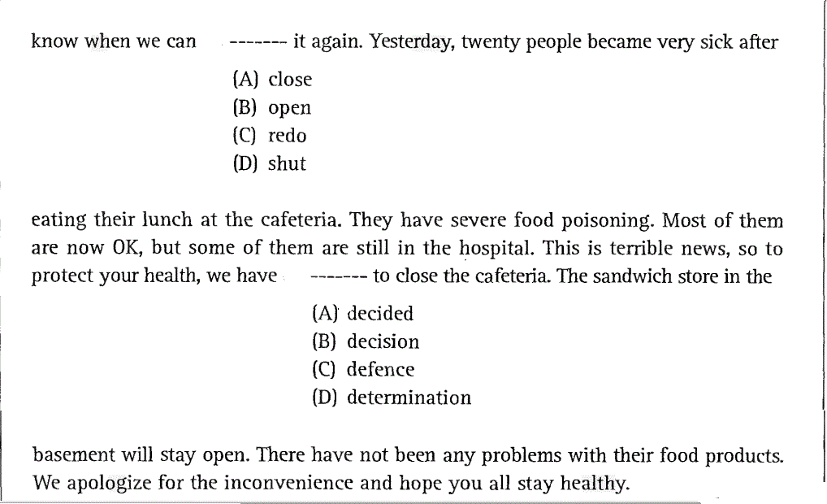

Questions 24 through 26 are based on the following memo.
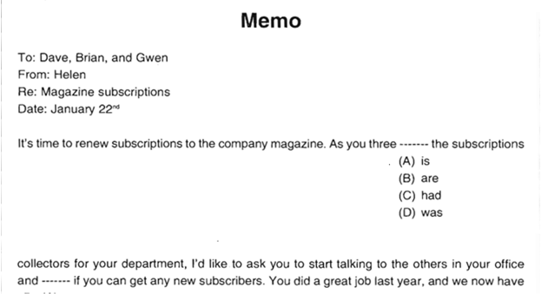
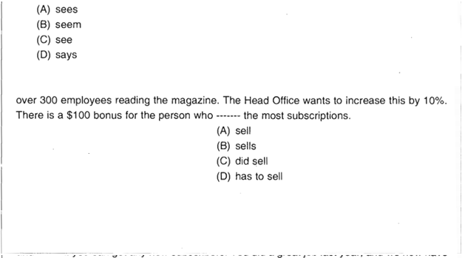

III. Reading comprehension
Choose the best answer.
Choose the best answer.
Questions 27 through 29 refer to the following advertisement.
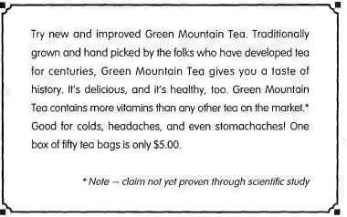

27.Which of the following is NOT true?
- Green Mountain Tea is delicious.
- Green Mountain Tea is good for toothaches.
- Green Mountain Tea is good for headaches.
- Green Mountain Tea is new.

28.How many tea bags are in one box?
- Twelve
- Twenty
- Fifteen
- Fifty
29.How much does it cost for one tea bag?
- $ 5.00
- $0.50
- $0.10
- $1.00
Questions 30 through 32 are based on the following reading.

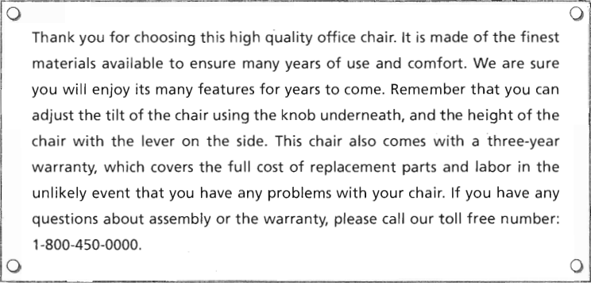

30. What kind of product is this information for?
- A kitchen appliance
- Furniture
- Electronics
- Sports equipment
- How long is this product guaranteed?
- Two months
- Three months
- Two years
- Three years
32.How can you adjust the height of this product?
- With a knob
- By tilting it
- With a lever
- By calling the toll free number

Questions 33 through 35 are based on the following chart.

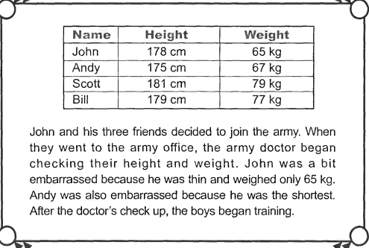

33.Who check their height?
- John
- Andy
- The doctor
- Bill
34.Who was embarrassed?
- John and Scott
- Bill and Scott
- Andy and the doctor
- Andy and John

35.Why did John and his friends go for a check up?
- Because John was sick
- Because they were sick
- Because they wanted to join the army
- Because John is a doctor

Questions 36 through 40 refer to the following memo and sign.
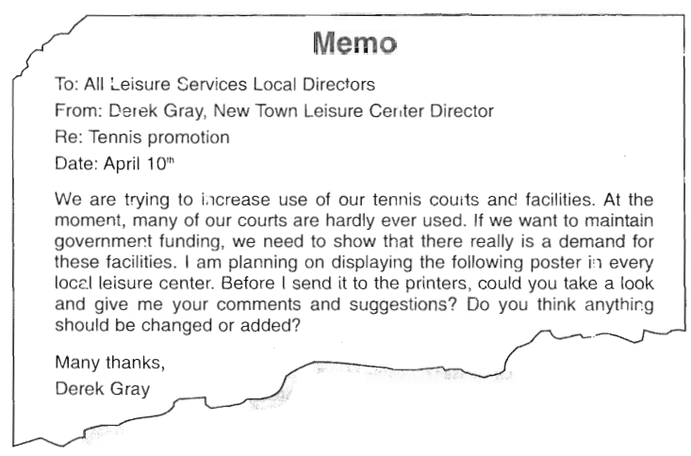
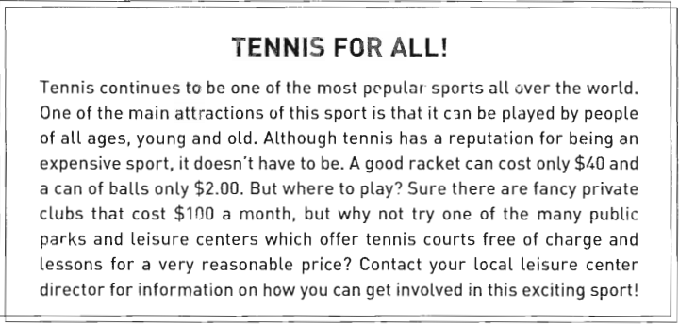
36. What is the purpose of this memo and sign?
(A) To encourage people to use public tennis courts
(B) To show the cost of the local tennis clubs
(C) To promote a new tennis club
(D) To ask for government funding

37. How is tennis usually categorized?
(A) Complicated
(B) Boring
(C) Expensive
(D) Affordable
38. Who can play this sport?
(A) Young people
(B) Middle aged people
(C) Old people
(D) People of all ages

39. Where is it expensive to play tennis?
(A) Park
(B) Private clubs
(C) Tournaments
(D) Schools
40.Who is Derek Gray?
(A) A tennis player
(B) A tennis club owner
(C) The manager of a sport center
(D) A film director

